AI Powered Future Trading Bot on IBKR

(Strategy Overview)

This strategy is based on LuxAlgo indicator.

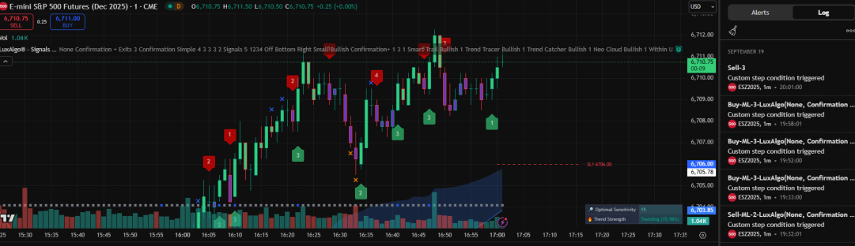

LuxAlgo is a good option to make strategy for the symbols which their trending is strong.

The most important thing is to set the point when it should buy and sell.

Based on LuxAlgo indicator, Signal is classified into 2 types.

* First one is Bullish.
* Second one is Bearish.

For each classified signals are applied to 4 types to analyse as 1, 2, 3, and 4.

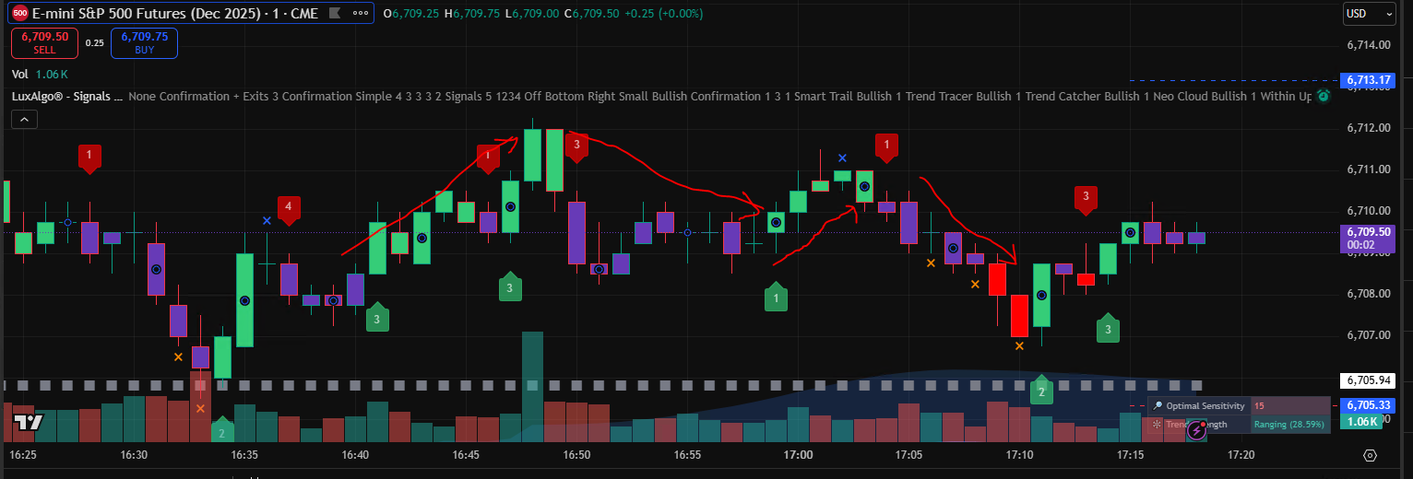

Number means signal's trending strength.

* When it buys?

In case of Bullish(3 and 4), it buys fixed position.

* When it sells?

In case of Bearish(2, 3 and 4), it cloese all positions.

It includes TP and SL implementation.

If current position is open, next time it must close all positions.

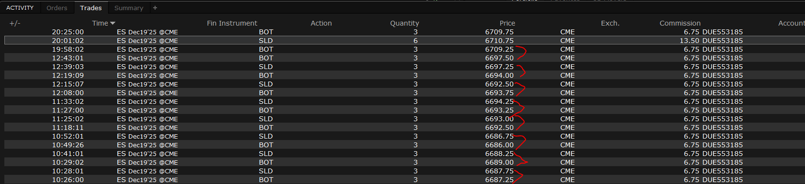

※Strategy Scalability.

1. Timescale of candle

2. Position amount

3. Other symbols

If you have any questions, plz let me ask to me.